Project Design Phase-II
Data Flow Diagram & User Stories

Date | 24 September 2026
Team ID | SWTID-2026-4084
Project Name | AI BlogNest API
Maximum Marks | 4 Marks

Data Flow Diagrams:
A Data Flow Diagram (DFD) is a traditional visual representation of the information flows within a system. A neat and clear DFD can depict the right amount of the system requirement graphically. It shows how data enters and leaves the system, what changes the information, and where data is stored.

Example:
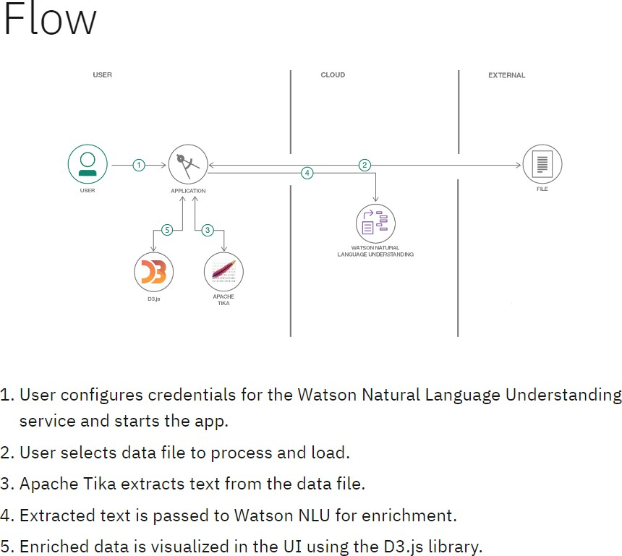

Example: DFD Level 0 (Industry Standard)
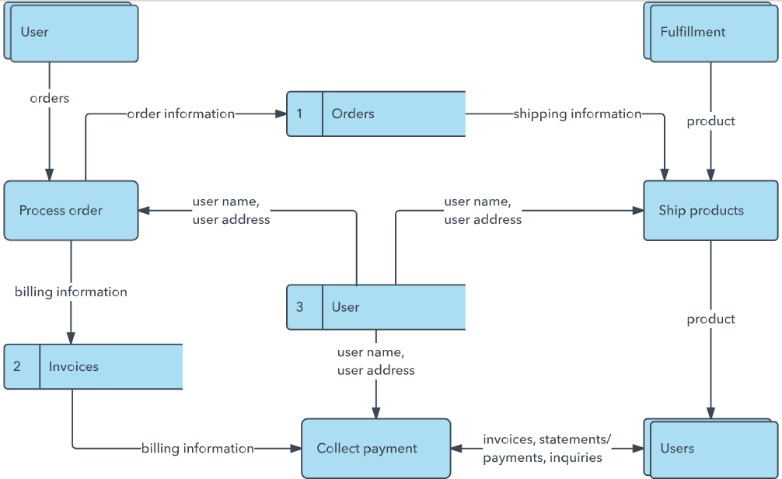

User Stories

User Type | Functional Requirement (Epic) | User Story Number | User Story / Task | Acceptance criteria | Priority | Release
User | Registration | USN-1 | As a user, I can register for the application by entering my email, password, and confirming my  password. | I can access my account / dashboard | High | Sprint-1
User | Login | USN-2 | As a user, I will receive confirmation email once I have registered for the  application | I can receive confirmation email & click confirm | High | Sprint-1
Author | Blog Management | USN-3 | As a user, I can register for the application through Facebook | I can register & access the dashboard with Facebook  Login | Low | Sprint-2
Author | Blog Management | USN-4 | As a user, I can register for the application through Gmail | Author can update and manage their own blog  content | Medium | Sprint-1
Reader | Login | USN-5 | As a user, I can log  into the application by | Published  blogs are | High | Sprint-1

 |  |  | entering email &  password | displayed  successfully.
User | Dashboard | USN-6 | As a user, I can generate blog content using AI by providing a topic. | AI generates relevant blog content based on the given  topic | High | Sprint-1
User | AI Blog Generation | USN-7 | As a user, I can generate a summary of a blog using AI. | The system generates a concise summary of the selected  blog. | High | Sprint-2
User | Comments | USN-8 | As a user, I can add comments to blog posts | The comment is successfully submitted and associated  with the blog. | Medium | Sprint-2
Admin | Comments | USN-9 | As an admin, I can manage user accounts and roles. | Admin can manage users and assign appropriate roles. | High | Sprint-2

